Portfolio Construction (Advanced)
Position Sizing, Risk Parity, Mean-Variance Optimisation & Constrained Portfolio Construction
Turning Validated Signals Into a Real, Risk-Controlled Portfolio
A Level 3 module in the Quantitative Finance Curriculum
Covers: Position sizing/volatility targeting/Kelly criterion · risk parity/ERC · mean-variance optimisation · factor/beta/dollar/volatility/sector-neutral constraints · exposure/turnover limits · transaction-cost-aware optimisation · robust optimisation/Black-Litterman/CVaR optimisation/hierarchical risk parity/dynamic optimisation (awareness)

Table of Contents
How to Use This Guide
What You Need to Know Before Starting
Understand Before Proceeding
Why It Matters
How This Connects to the Rest of the Curriculum
Glossary of Recurring Terms
Part 1 — Position Sizing, Volatility Targeting & the Kelly Criterion
1.1 From Signal to Position: Why Naive Sizing Fails
1.2 Volatility Targeting
1.3 The Kelly Criterion
Part 2 — Risk Parity and Equal Risk Contribution (ERC)
2.1 The Risk Parity Idea
2.2 The Equal Risk Contribution Math
2.3 Risk Parity vs. Equal-Weight vs. Mean-Variance
Part 3 — Mean-Variance Optimisation
3.1 The Markowitz Framework
3.2 The Efficient Frontier
3.3 Estimation Error: Why Naive MVO Misbehaves
Part 4 — Constraints: Factor, Beta, Dollar, Volatility & Sector Neutrality
4.1 Why a Good Signal Still Needs Constraints
4.2 The Common Neutrality Constraints
4.3 Exposure and Turnover Limits
Part 5 — Transaction-Cost-Aware Optimisation
5.1 Putting Costs Inside the Objective
5.2 Trading Off Alpha, Risk and Cost
Part 6 — Advanced & Robust Optimisation (Awareness)
6.1 Robust Optimisation
6.2 Black-Litterman
6.3 CVaR Optimisation
6.4 Hierarchical Risk Parity (HRP)
6.5 Dynamic Optimisation
Practical Exercise
Common Beginner Mistakes
Advanced Extensions
Professional Applications
Where to Go Next

How to Use This Guide
This document is a companion to Portfolio Construction (Advanced), the third-level module in the quantitative finance curriculum. It covers how one or more validated trading signals are turned into an actual, risk-controlled portfolio of positions — sizing, combining, constraining, and rebalancing it in a way that a real trading desk could run.
The module is self-contained: every concept is introduced from first principles, paired with a worked numerical example and a short runnable Python sketch, and illustrated with a chart wherever a picture makes the idea land faster than a formula alone. Read it start to finish if portfolio construction is new to you, or jump straight to the part you need.

What You Need to Know Before Starting
- Optimisation (Level 1) — comfort with the idea of a constrained objective function, gradients, and what it means to numerically search for a minimum or maximum; mean-variance and ERC optimisation in Parts 2–3 are direct applications of this.
- Risk Metrics — volatility, covariance, and value-at-risk as ways of measuring risk; this module assumes you can already compute and interpret a covariance matrix and a portfolio volatility.
- Regression / Factor Models — beta and factor exposures as regression coefficients of an asset's returns on a market or factor return; Part 4's neutrality constraints are expressed directly in these terms.

Understand Before Proceeding
Prerequisite gate —
Do not treat portfolio construction as a bolt-on step that happens automatically once a signal is validated. A signal's research Sharpe ratio describes a bet, not a portfolio: how much of that bet to take, how to combine it with other bets, and how tightly to constrain the incidental exposures it creates, determine most of the difference between a signal that looks good on paper and a strategy that survives live trading.

Why It Matters
A great signal poorly sized, or poorly combined with other positions, can still lose money or take on unintended risk. Two managers can hold the exact same three signals and produce completely different outcomes purely because of how those signals were sized, blended, and constrained — one runs a diversified, risk-balanced book, while the other unknowingly runs a concentrated bet on whichever signal happened to be the most volatile. Construction is the step where research becomes an actual, tradeable portfolio, and it is where a large share of a strategy's real-world Sharpe ratio is won or lost.

How This Connects to the Rest of the Curriculum
- Research — Multiple validated signals must be combined with sizing and neutrality constraints; this is where single-strategy research becomes a book. A signal that looked excellent in isolation may need to be down-weighted once its correlation to existing book risk is accounted for.
- Development — Constraint-aware optimisation code and turnover-cost-aware rebalancing logic are non-trivial infrastructure — a naive quadratic-programming call is rarely enough once real-world constraints, transaction costs, and daily rebalancing are involved.
- Trading — Sector/beta/dollar neutrality mandates are common desk-level risk constraints in live trading; a portfolio manager is frequently required to report and defend these exposures to a risk desk in real time.

Glossary of Recurring Terms
Position sizing — The process of deciding how much capital (or risk) to allocate to a given signal or asset, as distinct from deciding whether to hold it at all.
Volatility targeting — Scaling a position's size inversely with its (realised or forecast) volatility so that it contributes a chosen, constant amount of risk to the portfolio over time.
Kelly criterion — A position-sizing rule that maximizes the long-run expected logarithmic growth rate of capital, given a bet's win probability and payoff odds.
Risk parity — A portfolio construction approach that allocates capital so that every asset or signal contributes an equal share of total portfolio risk, rather than an equal share of capital.
Equal Risk Contribution (ERC) — The specific optimisation problem solved to build a risk-parity portfolio: find weights such that each position's marginal contribution to total portfolio variance is identical.
Mean-variance optimisation (MVO) — The Markowitz framework for choosing portfolio weights that maximize expected return for a given level of variance, or minimize variance for a given level of expected return.
Efficient frontier — The set of portfolios that offer the highest expected return achievable for each level of risk (or, equivalently, the lowest risk for each level of expected return).
Factor-neutral / beta-neutral — A constraint that the portfolio's net exposure to a specified factor (e.g. market beta, a style factor) is held at or near zero, so returns are driven by stock selection rather than that factor's movements.
Dollar-neutral — A constraint that total long dollar exposure equals total short dollar exposure, so the portfolio has (approximately) zero net market exposure.
Turnover — The rate at which a portfolio's positions are traded and replaced, usually expressed as a fraction (or multiple) of the portfolio's value traded per period.
Transaction-cost-aware optimisation — An optimisation that includes the expected cost of trading directly in its objective function, rather than treating costs as an afterthought applied to a paper portfolio.
Robust optimisation — An optimisation approach that explicitly accounts for uncertainty in its input estimates (expected returns, covariances), producing weights that degrade more gracefully when those estimates are wrong.
Black-Litterman model — A framework for blending market-implied equilibrium returns with an investor's own subjective views, producing more stable and intuitive portfolio weights than plugging raw view-based estimates into mean-variance optimisation.
CVaR (Conditional Value-at-Risk) — The expected loss in the worst-case tail of the return distribution beyond a chosen probability threshold; CVaR optimisation minimizes this tail-risk measure directly rather than variance.
Hierarchical Risk Parity (HRP) — A portfolio construction method that uses the hierarchical (tree) correlation structure of assets, rather than matrix inversion, to allocate risk — numerically stable even for large, highly correlated portfolios.

Part 1 — Position Sizing, Volatility Targeting & the Kelly Criterion
Every signal answers the question "which direction, and how confidently?" Position sizing answers a different question entirely: "how much capital, or how much risk, should this conviction actually receive?" Get sizing wrong and even a genuinely predictive signal can produce a portfolio that is either too timid to matter or so aggressive that a short losing streak wipes out months of gains.

1.1 From Signal to Position: Why Naive Sizing Fails
The simplest possible rule — give every signal, or every asset, an equal dollar weight — ignores the fact that assets and signals differ enormously in volatility. A signal on 3-month Treasury futures and a signal on a small-cap biotech stock might both be "one unit of conviction," but an equal-dollar position in the biotech name will dominate the portfolio's risk. Naive equal weighting silently converts a diversified-looking portfolio into a concentrated bet on whichever asset happens to be the most volatile.
Tip —
A fast diagnostic: compute each position's contribution to total portfolio risk (Section 2.2 gives the exact formula). If one position's risk contribution is far out of proportion to how confident you actually are in it, sizing — not the signal itself — is usually the problem.

1.2 Volatility Targeting
Volatility targeting fixes the equal-dollar problem directly: instead of sizing by capital, size inversely by volatility, so every position contributes the same amount of risk. For a position sized to a target annualized volatility σ_target, given the asset's own forecast volatility σ_i:
weight_i = ( σ_target / σ_i ) × k
where k is a normalizing constant chosen so the weights sum to the desired total (gross) exposure. The forecast σ_i itself is typically an exponentially-weighted or rolling-window realised volatility, since true future volatility is never directly observable.
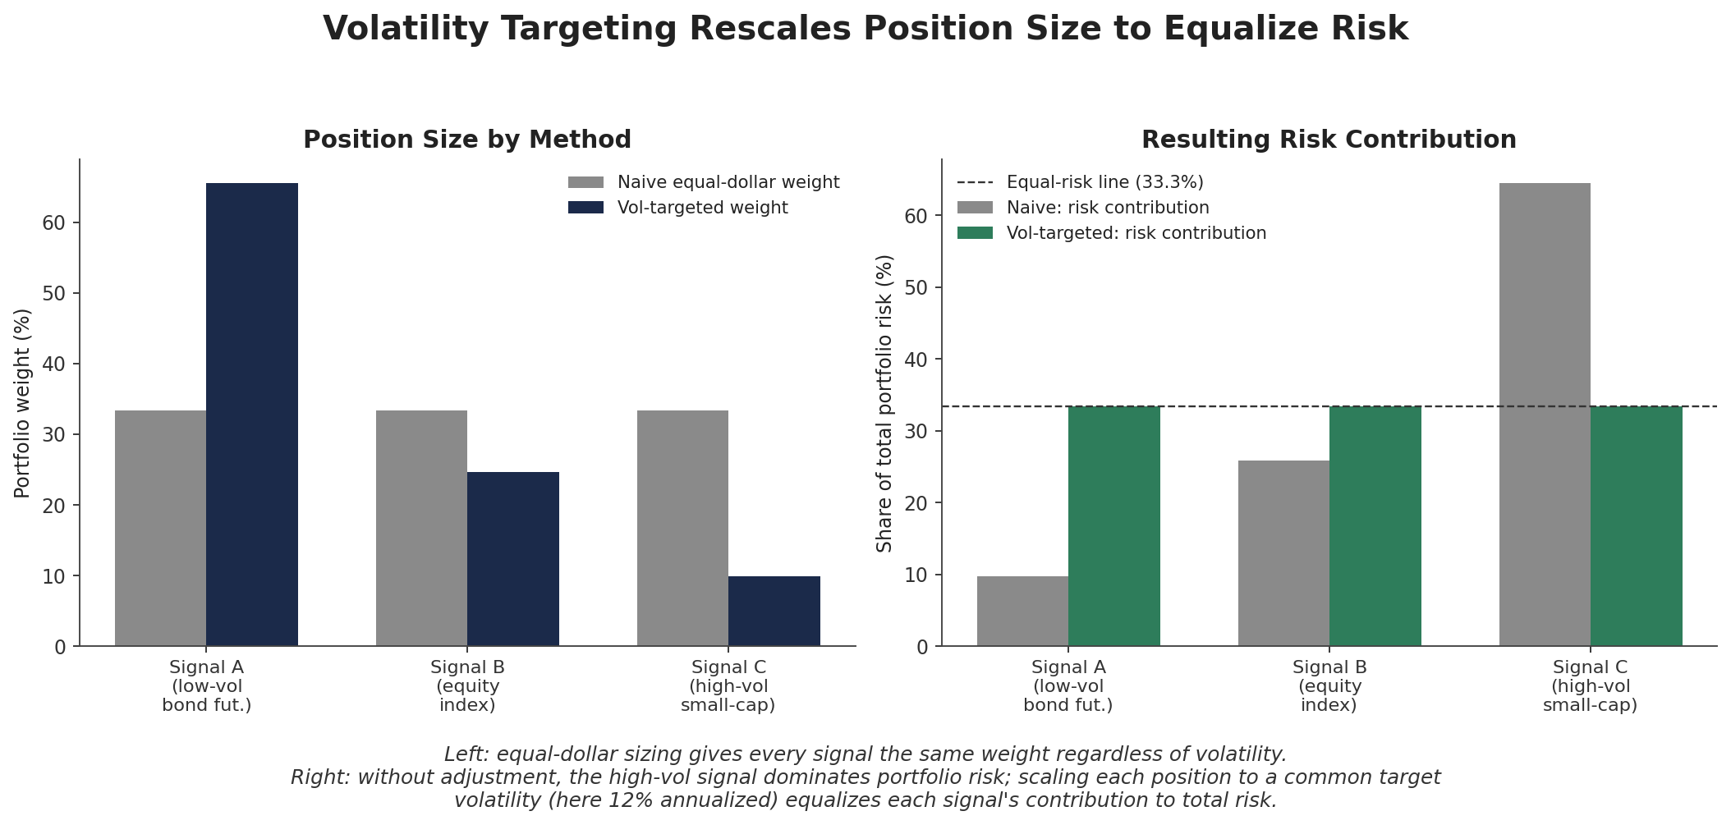
Figure 1.1 — Equal-dollar sizing (left, grey) ignores volatility differences; the resulting risk contribution (right, grey) is dominated by the highest-volatility signal. Vol-targeted sizing (navy/green) rescales positions so each signal contributes an equal share of total risk.
import numpy as np

ann_vol = np.array([0.06, 0.16, 0.40]) # forecast annualized vol per signal
target_vol = 0.12 # desired risk contribution per signal

raw_weight = target_vol / ann_vol
weight = raw_weight / raw_weight.sum() # normalize to sum to 1
# weight ≈ [0.606, 0.227, 0.091] -- the low-vol signal gets sized up, not down
Note the counterintuitive result: the lowest-volatility signal receives the largest weight, since it takes a bigger position in a quiet asset to generate the same risk as a smaller position in a volatile one. Volatility targeting is also commonly applied at the whole-portfolio level — scaling total gross exposure up in calm markets and down in turbulent ones — which is the basic mechanism behind most "vol-targeting" or "risk-parity" overlay strategies reported in the press.

1.3 The Kelly Criterion
Volatility targeting answers "how much risk per position," but not "how much total risk should the portfolio take at all." The Kelly criterion, originally derived for repeated favourable bets, answers exactly that: it finds the fraction of capital to risk that maximizes the long-run expected logarithmic growth rate of wealth. For a simple bet with win probability p and payoff odds b (win b dollars per dollar bet, lose 1 dollar per dollar bet):
f* = p − (1 − p) / b
In a trading context, an approximate continuous analogue is more commonly used, expressing the optimal fraction of capital allocated to a strategy in terms of its expected excess return and variance:
f* ≈ μ / σ² (excess return μ, variance σ², continuous-time approximation)
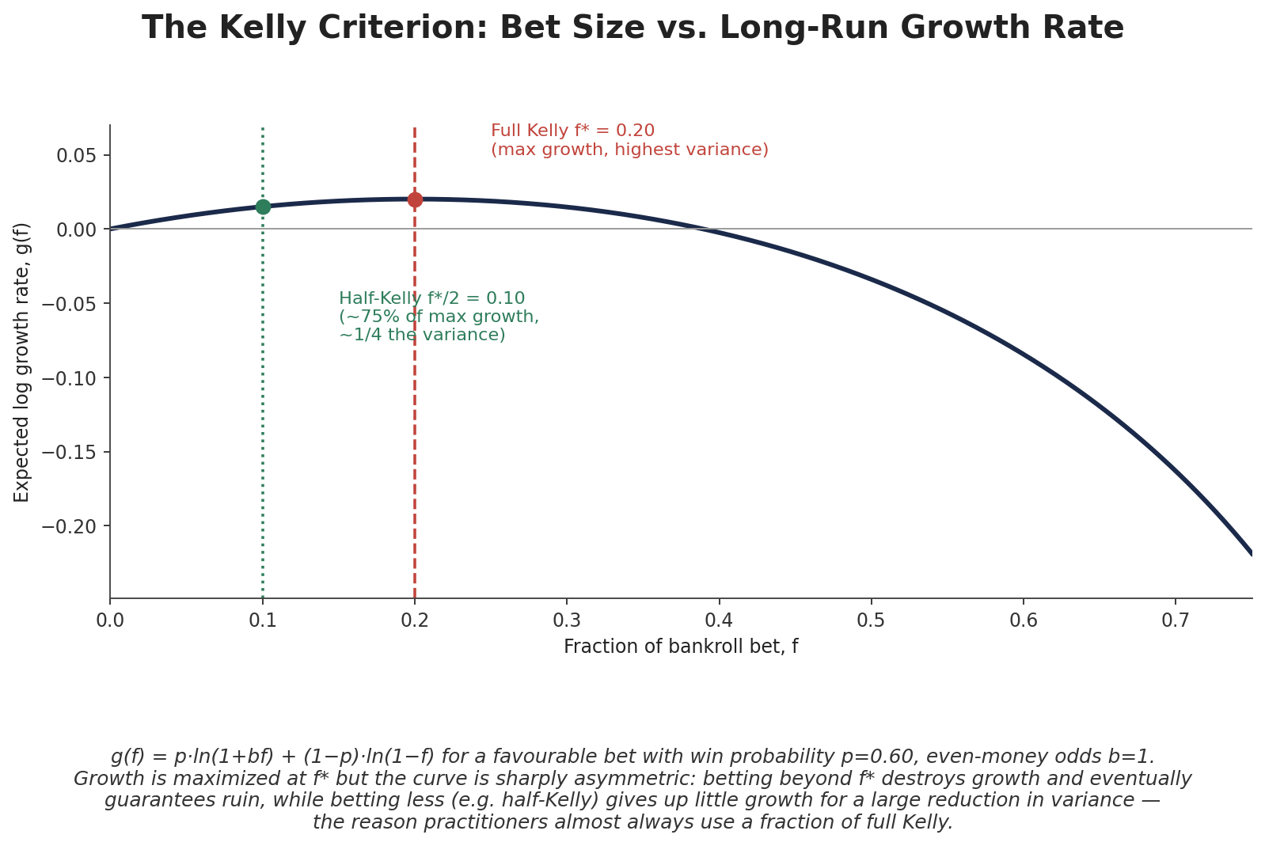
Figure 1.2 — The Kelly growth curve is sharply asymmetric around its peak f*. Overbetting even slightly past f* destroys long-run growth and, taken far enough, guarantees eventual ruin; underbetting relative to f* gives up comparatively little growth for a large reduction in variance.
Tip — Fractional Kelly is the practical standard
Full Kelly (f*) is rarely used directly: it assumes the inputs (p, b, or μ and σ²) are known exactly, and real estimates are always noisy. Overestimating the edge and betting full Kelly on the true, smaller edge can be ruinous. Most practitioners run at a fraction of full Kelly — commonly one-half ("half-Kelly") or one-quarter — trading a modest amount of expected growth for a large reduction in variance and estimation-error risk.

# Continuous-time Kelly fraction for a strategy with a Sharpe ratio
mu, sigma = 0.08, 0.15 # expected excess return, volatility (annualized)
f_star = mu / sigma**2
half_kelly = f_star / 2
# f_star ≈ 3.56x leverage on capital; half_kelly ≈ 1.78x -- a reminder that
# 'full Kelly' is frequently far more leverage than any real portfolio would run

Part 2 — Risk Parity and Equal Risk Contribution (ERC)
Section 1.2 showed how to volatility-target a single position in isolation. Risk parity extends the same idea to an entire portfolio of correlated assets or signals: rather than equalizing each position's standalone volatility, it equalizes each position's contribution to the volatility of the whole portfolio — a subtly but importantly different target once correlation is in the picture.

2.1 The Risk Parity Idea
Consider a simple multi-asset portfolio: equities, government bonds, credit, and commodities. Equal-dollar weighting overwhelmingly concentrates risk in equities and commodities, since bonds are far less volatile. A risk-parity portfolio instead asks: what weights make every asset's contribution to total portfolio risk equal, given not just each asset's own volatility but also how it moves together with everything else?

2.2 The Equal Risk Contribution Math
For a portfolio with weight vector w and covariance matrix Σ, total portfolio variance is w' Σ w. Each asset's marginal contribution to that variance, and its total (risk) contribution, are:
Marginal Risk Contribution_i = (Σw)_i Risk Contribution_i = w_i × (Σw)_i
The risk contributions of all assets sum exactly to total portfolio variance, so each one's percentage share is RC_i / (w'Σw). The ERC portfolio is the weight vector w that makes every asset's percentage risk contribution equal to 1/N for N assets. There is no closed-form solution in general (unlike mean-variance optimisation's matrix algebra); ERC weights are found by numerical iteration.
import numpy as np

def risk_contributions(w, cov):
port_var = w @ cov @ w
marginal = cov @ w
return w * marginal / port_var # sums to 1.0 across assets

def erc_weights(cov, n_iter=200):
n = cov.shape[0]
w = 1 / np.sqrt(np.diag(cov)) # naive inverse-vol start
w /= w.sum()
target = 1 / n
for _ in range(n_iter): # simple fixed-point iteration
rc = risk_contributions(w, cov)
w *= target / rc
w /= w.sum()
return w
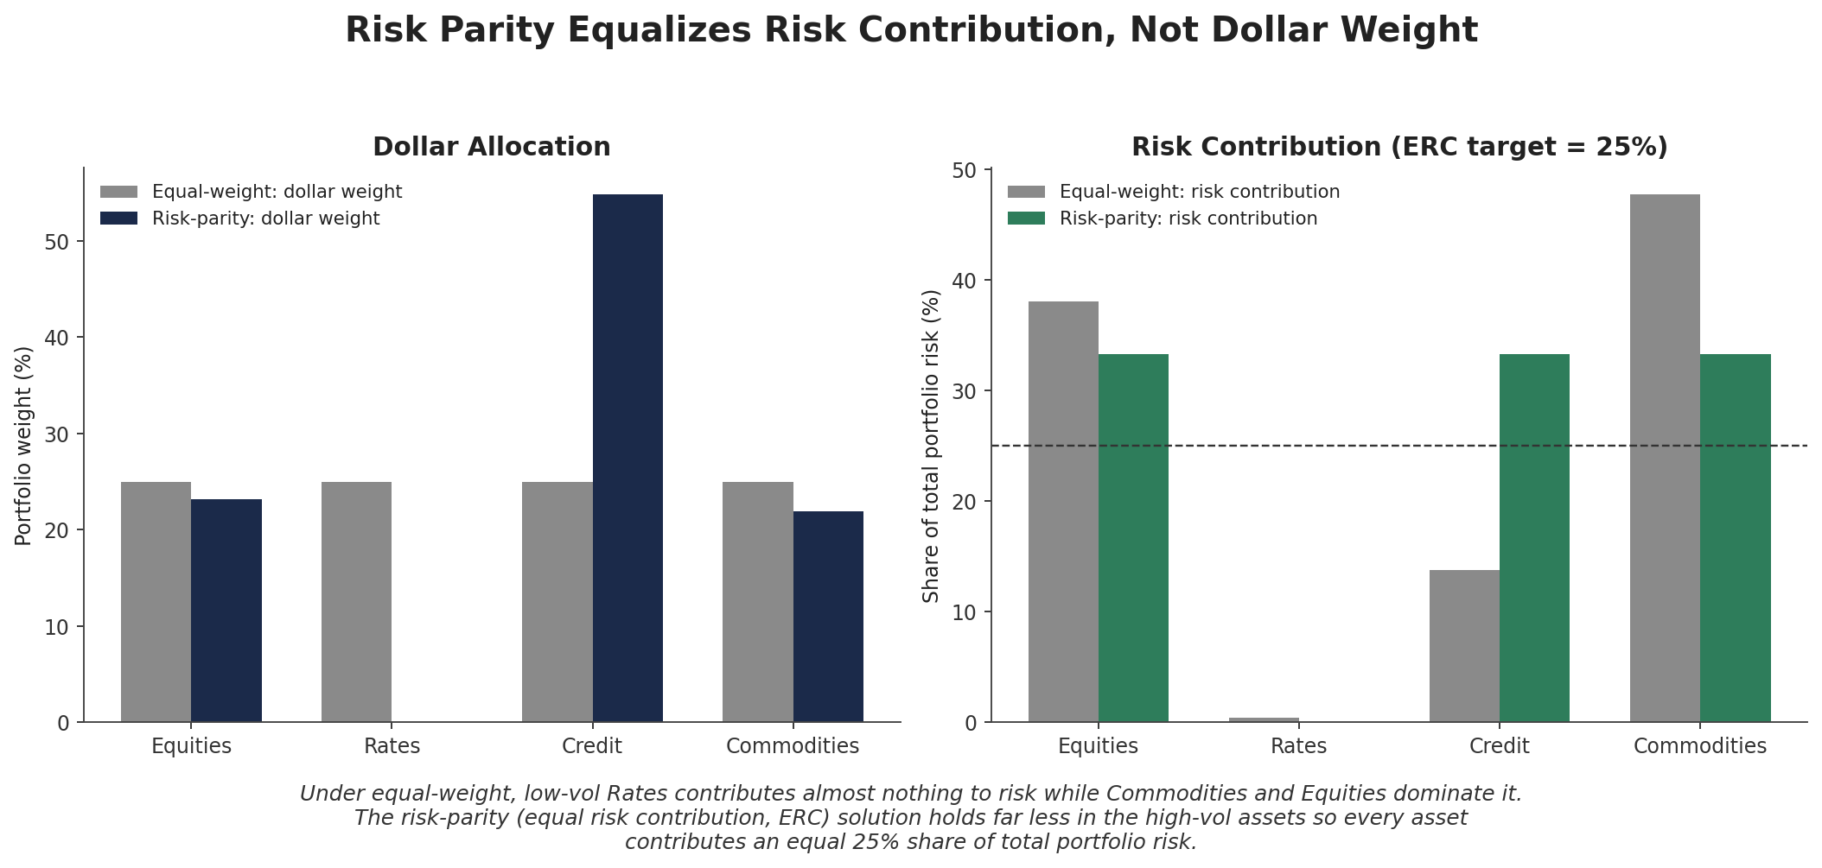
Figure 2.1 — Under equal-dollar weighting, low-volatility Rates contributes almost nothing to portfolio risk while Equities and Commodities dominate it. The risk-parity solution holds far more in Rates (and less in the volatile assets) so every asset contributes an identical 25% share of total portfolio risk.

2.3 Risk Parity vs. Equal-Weight vs. Mean-Variance
Risk parity sits deliberately between two extremes. Equal-weighting ignores risk information entirely; mean-variance optimisation (Part 3) uses expected-return information directly, which makes it far more sensitive to estimation error, since expected returns are notoriously difficult to forecast accurately while volatilities and correlations are comparatively stable. Risk parity uses only the covariance matrix — deliberately staying silent on expected returns — which is precisely why it tends to be more robust out-of-sample, at the cost of not using any return forecast at all.
Approach | Uses expected returns? | Uses covariance? | Typical robustness
Equal-weight | No | No | Robust, but ignores all risk & return information
Risk parity / ERC | No | Yes | Robust; sensitive only to (stabler) covariance estimates
Mean-variance (MVO) | Yes | Yes | Most information-rich; most sensitive to estimation error

Part 3 — Mean-Variance Optimisation
Mean-variance optimisation (MVO), developed by Harry Markowitz in 1952, is the foundational framework of modern portfolio theory: given expected returns and a covariance matrix for a set of assets, find the portfolio weights that deliver the best possible trade-off between expected return and risk.

3.1 The Markowitz Framework
For a portfolio with weights w, expected returns μ, and covariance matrix Σ, the classic formulation minimizes variance subject to a target expected return:
min_w w' Σ w subject to: w' μ = μ_target, w' 1 = 1
Equivalently, the problem can be framed as maximizing risk-adjusted return directly — maximizing the portfolio's Sharpe ratio — which produces the tangency portfolio described in Section 3.2:
max_w ( w'μ − r_f ) / √(w'Σw)

3.2 The Efficient Frontier
Solving the minimum-variance problem for every achievable target return traces out the efficient frontier: the curve of portfolios offering the lowest possible risk for each level of expected return. Any portfolio below the frontier is strictly dominated — some portfolio on the frontier offers the same return for less risk, or more return for the same risk. The point where a line from the risk-free rate is tangent to the frontier identifies the maximum-Sharpe-ratio ("tangency") portfolio; combining it with cash or leverage produces every efficient risk/return combination on the Capital Market Line.
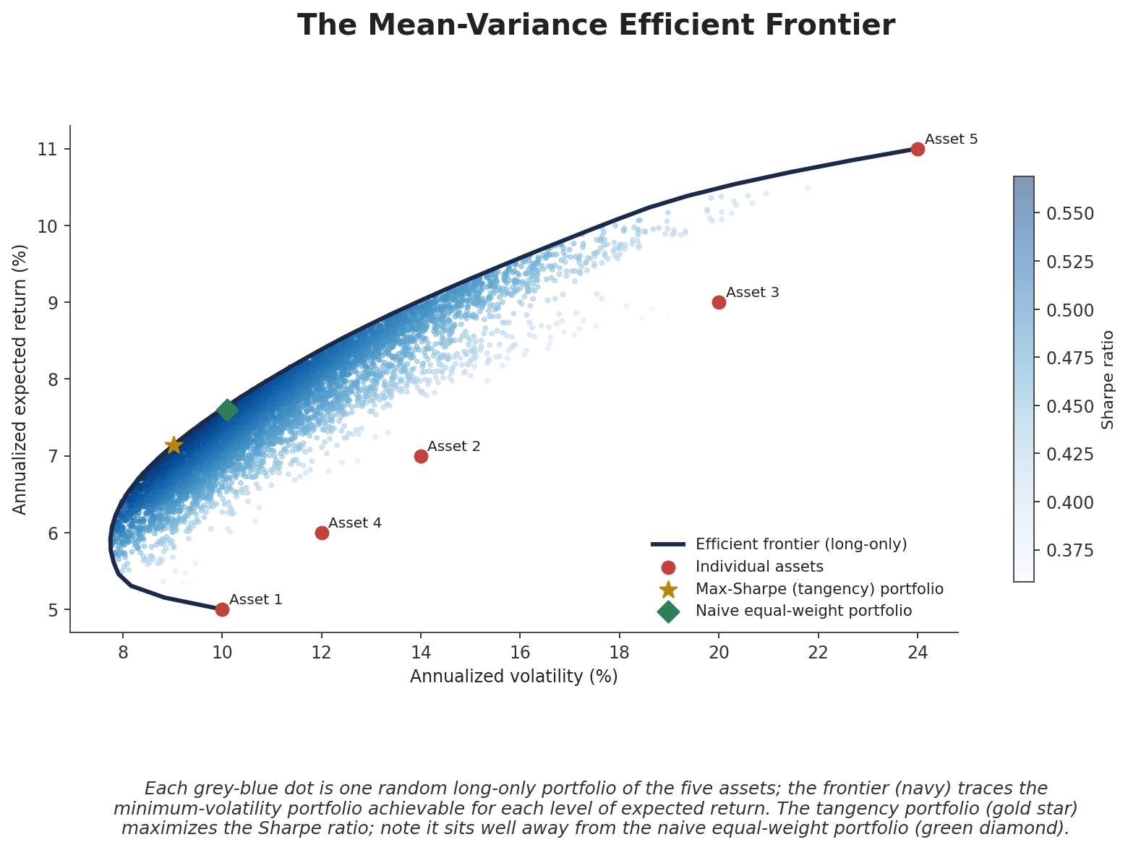
Figure 3.1 — Every light dot is one random long-only portfolio of five assets; the navy curve traces the minimum achievable volatility for each level of expected return. The tangency (max-Sharpe) portfolio, gold star, sits well away from — and dominates — the naive equal-weight portfolio, green diamond.
import numpy as np
from scipy.optimize import minimize

def min_var_for_target(mu, cov, target_ret):
n = len(mu)
cons = [{'type': 'eq', 'fun': lambda w: w.sum() - 1},
{'type': 'eq', 'fun': lambda w: w @ mu - target_ret}]
bounds = [(0, 1)] * n # long-only
res = minimize(lambda w: w @ cov @ w, np.ones(n)/n,
method='SLSQP', bounds=bounds, constraints=cons)
return res.x

3.3 Estimation Error: Why Naive MVO Misbehaves
Prerequisite gate —
Do not treat a mean-variance optimiser as a black box that finds "the" optimal portfolio. Its output is only as reliable as its inputs, and expected returns in particular are estimated with enormous uncertainty — a small change in the assumed μ vector can swing optimal weights wildly, often toward extreme, concentrated, and highly unintuitive long/short positions. This sensitivity is precisely why risk parity (Part 2), robust optimisation, and Black-Litterman (Part 6) exist.

In practice, naive ("textbook") MVO run on raw historical estimates of μ and Σ is rarely used directly by professional managers for exactly this reason. Section 6.2's Black-Litterman model and Section 6.4's Hierarchical Risk Parity are two of the standard responses to this estimation-error problem, alongside simpler fixes such as shrinking the covariance matrix and imposing tight position bounds.

Part 4 — Constraints: Factor, Beta, Dollar, Volatility & Sector Neutrality
An unconstrained optimiser chasing pure signal will happily load up on whatever incidental exposures make the objective function look best — a large net sector tilt, a heavy market beta, a lopsided long/short imbalance — none of which were an intended view. Constraints are how a desk keeps a portfolio expressing only the bets it actually wants to take.

4.1 Why a Good Signal Still Needs Constraints
A stock-selection signal, run unconstrained, is free to satisfy its objective in whatever way is mathematically convenient — which very often means concentrating in a handful of correlated names within one sector, or building up a large net market exposure that has nothing to do with the underlying insight. Constraints force the optimiser to express the signal within the sector, factor, or beta-neutral "lanes" that the strategy is actually meant to occupy.

4.2 The Common Neutrality Constraints
- Beta-neutral — net portfolio beta to the market (or a chosen benchmark) held near zero, so P&L is driven by stock selection rather than market direction.
- Factor-neutral — net exposure to a specified style factor (e.g. value, momentum, size) held near zero, isolating the signal from broad factor moves it wasn't designed to capture.
- Dollar-neutral — total long dollar exposure equals total short dollar exposure, so net market exposure is approximately zero regardless of beta.
- Volatility-neutral — the portfolio's realised or forecast volatility is held near a target level over time, tying back directly to Section 1.2's volatility targeting.
- Sector-neutral — net exposure within each sector (or industry group) held near zero, so the portfolio expresses stock selection inside sectors rather than a directional sector call.
Constraint form: | w' e_sector,k | ≤ ε for each sector k
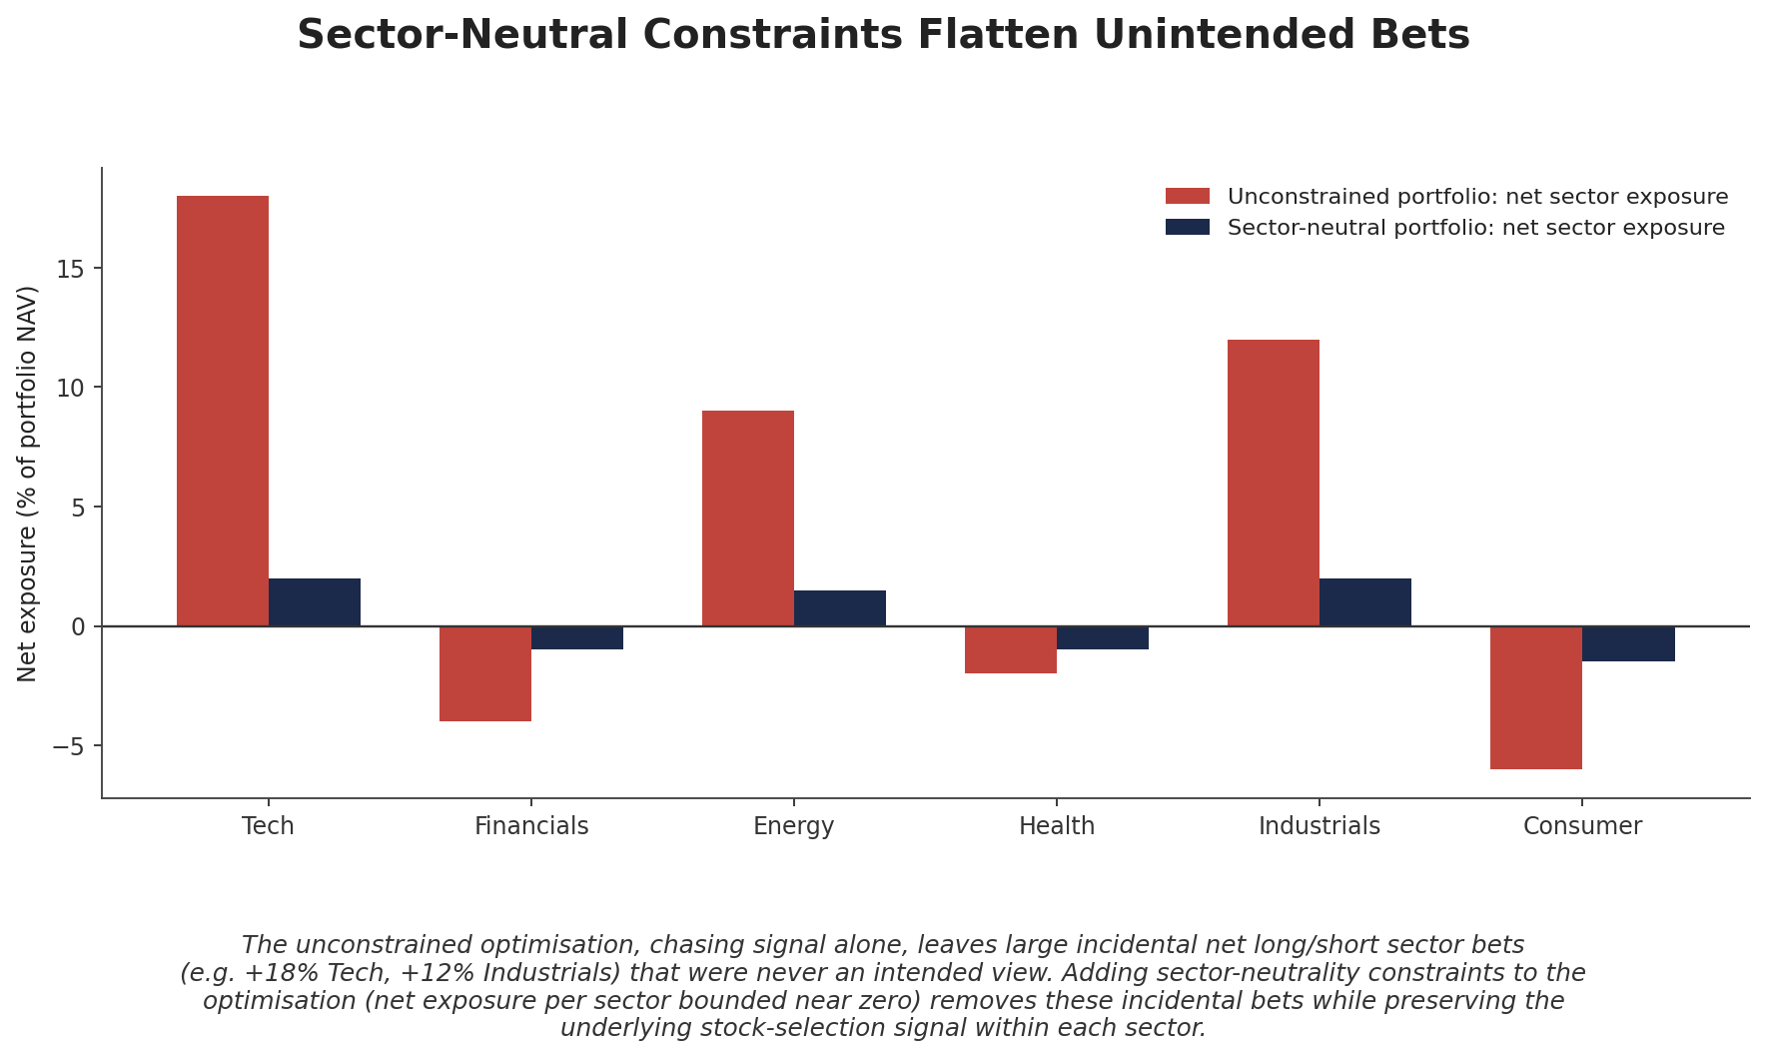
Figure 4.1 — Left unconstrained, the optimiser leaves large incidental net sector bets (e.g. +18% Tech). Bounding each sector's net exposure near zero removes these unintended tilts while preserving the underlying stock-selection signal within each sector.

4.3 Exposure and Turnover Limits
Beyond neutrality, most mandates impose simple exposure limits directly: a maximum position size per name, a maximum gross exposure (sum of absolute position sizes, often expressed as a percentage of NAV, e.g. 200% gross for a 2x-levered long/short book), and a maximum net exposure. Turnover limits — a cap on how much of the portfolio can be traded per period — exist for a different reason entirely: controlling transaction costs, which is the subject of Part 5.
# Typical constraint block added to an optimisation, in words:
# 1. sum(weights) == 1 (fully invested)
# 2. abs(weights).sum() <= 2.0 (200% gross exposure cap)
# 3. sum(weights) == 0 (dollar-neutral)
# 4. abs(weights @ betas) <= 0.05 (beta-neutral, +/-5%)
# 5. abs(sector_matrix @ weights) <= 0.02 (sector-neutral, +/-2% per sector)
# 6. abs(weights - w_previous).sum() <= 0.20 (turnover cap, 20% one-way per rebalance)

Part 5 — Transaction-Cost-Aware Optimisation
A portfolio that looks excellent on paper can be unprofitable to actually trade if the optimisation ignores what it costs to get into (and out of) positions. Transaction-cost-aware optimisation folds an explicit cost estimate into the objective, so the optimiser only trades when the expected benefit outweighs the expected cost of doing so.

5.1 Putting Costs Inside the Objective
Rather than maximizing raw expected return net of a risk penalty, a cost-aware objective subtracts an explicit trading-cost term based on how far the new weights w are from the current weights w_prev:
max_w w'α − λ · w'Σw − κ · | w − w_prev |
Here α is expected (alpha) return, λ is the usual risk-aversion parameter penalizing variance, and κ scales the cost of trading — typically itself a function of each asset's own liquidity and bid-ask spread, and often modelled as increasing (super-linearly) with trade size to reflect market impact on larger orders.
# Simplified cost-aware objective (linear cost term)
def objective(w, w_prev, alpha, cov, lam, kappa):
ret = w @ alpha
risk_penalty = lam * (w @ cov @ w)
cost_penalty = kappa * np.abs(w - w_prev).sum()
return -(ret - risk_penalty - cost_penalty) # minimize the negative

5.2 Trading Off Alpha, Risk and Cost
As a signal's information decays and gets refreshed, a pure alpha-maximizing rebalance keeps chasing the newest estimate, pushing turnover ever higher. But each additional unit of turnover captures shrinking marginal alpha (most of the benefit was already captured by earlier, cheaper trades) while paying the full marginal cost of that trade. The cost-aware optimum is the point where marginal alpha capture just equals marginal transaction cost — beyond it, trading harder actually reduces net returns.
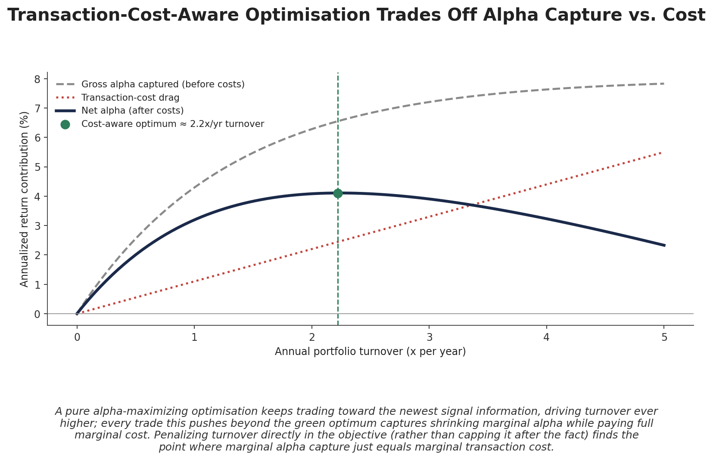
Figure 5.1 — Gross alpha captured (grey, dashed) rises with turnover but with diminishing returns, while cost drag (red, dotted) rises roughly linearly. Net alpha (navy) is maximized at a moderate turnover level, not the highest one achievable.
Common beginner mistake —
Backtesting a strategy gross of transaction costs, seeing an attractive Sharpe ratio, and only checking costs as a final sanity check. High-turnover strategies in particular can see most or all of their apparent edge consumed by costs once modelled honestly — cost-awareness belongs inside the optimisation, not bolted on afterward.

Part 6 — Advanced & Robust Optimisation Approaches (Awareness)
The remaining approaches below are covered at an awareness level: know what each one is, what problem it solves, and roughly how it works, without expecting to derive or implement it from scratch yet. Each is treated in full technical depth in Level 5–6 modules.

6.1 Robust Optimisation
Robust optimisation directly addresses Section 3.3's estimation-error problem by optimizing against the worst case within a plausible range (an "uncertainty set") around the estimated inputs, rather than treating point estimates of μ and Σ as exact. The result is typically a more conservative, better-diversified portfolio that degrades more gracefully when the original estimates turn out to be wrong — at the cost of some performance in the scenario where the estimates happened to be exactly right.

6.2 Black-Litterman
The Black-Litterman model addresses a different, very practical problem: raw historical expected returns fed directly into MVO tend to produce extreme, unintuitive weights (Section 3.3). Black-Litterman starts instead from market-implied equilibrium returns (reverse-engineered from current market-cap weights) and then blends in the investor's own specific views, with the blend weighted by the investor's stated confidence in each view:
E[R] = [ (τΣ)⁻¹ + P'ΩP ]⁻¹ [ (τΣ)⁻¹Π + P'ΩQ ]
where Π is the equilibrium return vector, P and Q encode the investor's views and their magnitudes, and Ω represents the investor's uncertainty about those views. The exact matrix algebra is a Level 5–6 topic; the concept to retain here is that Black-Litterman produces far more stable, intuitive weights than feeding subjective views directly into a mean-variance optimiser.

6.3 CVaR Optimisation
Mean-variance optimisation penalizes variance symmetrically — a large unexpected gain is penalized exactly as much as a large unexpected loss of the same size. Conditional Value-at-Risk (CVaR) optimisation instead minimizes the expected loss within the worst tail of the return distribution beyond a chosen confidence level (e.g. the average loss in the worst 5% of outcomes), which is often a more decision-relevant measure of risk for strategies with meaningfully skewed or fat-tailed return distributions, such as option-selling or credit strategies.

6.4 Hierarchical Risk Parity (HRP)
Both mean-variance optimisation and standard ERC require inverting a covariance matrix, which becomes numerically unstable as the number of assets grows and correlations become high — small estimation errors get amplified into large, erratic weight swings. Hierarchical Risk Parity sidesteps matrix inversion entirely: it clusters assets into a correlation-based hierarchy (a dendrogram, much like hierarchical clustering in machine learning), then allocates risk recursively down that tree, splitting risk equally between each pair of clusters at every branch. The result tends to be markedly more numerically stable for large portfolios than either MVO or matrix-based ERC.

6.5 Dynamic Optimisation
Every approach so far treats each rebalance as a fresh, single-period optimisation. Dynamic optimisation instead explicitly plans across multiple future periods at once, accounting for how today's trade affects the cost and opportunity set of tomorrow's trade — most relevant when transaction costs are large relative to alpha decay, so that trading patiently over several periods dominates an aggressive single-period rebalance. This connects directly back to Part 5's transaction-cost-aware framework, extended across time.

Practical Exercise
Build a volatility-targeted, sector-neutral portfolio from three independent signals, and compare it to a naive equal-weighted combination.
- Step 1 — Take three independent signals (e.g. a momentum signal, a value signal, and a low-volatility signal) each expressed as a vector of position scores across a universe of stocks.
- Step 2 — Combine the three signals with a naive equal-weighted average to form a baseline portfolio, and separately size each signal using volatility targeting (Section 1.2) before combining.
- Step 3 — Apply a sector-neutral constraint (Section 4.2) to the vol-targeted combination, bounding net exposure per sector near zero.
- Step 4 — Compare the two resulting portfolios' realised volatility, per-signal risk contribution, and net sector exposures — the naive combination should show uneven risk contribution and material incidental sector tilts that the constrained, vol-targeted version does not.

Common Beginner Mistakes
- Combining signals by simple averaging without considering their correlation and relative volatility — two highly correlated signals averaged together effectively double-count the same bet, while a naive average also lets the highest-volatility signal dominate risk exactly as in Section 1.1.
- Ignoring transaction costs in the optimisation objective, producing a paper portfolio that is unprofitable to actually trade — Part 5 covers directly why costs belong inside the optimisation, not applied as an afterthought.

Advanced Extensions
- Black-Litterman for incorporating subjective views into equilibrium-anchored expected returns (Section 6.2), covered in full mathematical depth at Level 5–6.
- Hierarchical Risk Parity for numerically stable construction of large portfolios without matrix inversion (Section 6.4), also a Level 5–6 topic.

Professional Applications
- Multi-strategy portfolio management — allocating capital across many live signals or sub-strategies inside a single book, using exactly the sizing, risk-parity, and constraint machinery covered in this module.
- Capital allocation across signals — a portfolio manager or CIO deciding how much risk budget each research signal or desk receives is, mechanically, solving a risk-parity or mean-variance-style allocation problem at a higher level of aggregation.

Where to Go Next
This module assumed access to already-validated signals; the Research curriculum's signal validation modules cover how those signals are built and tested in the first place. The Development curriculum's infrastructure modules cover how constraint-aware, cost-aware optimisation and rebalancing logic are implemented as production systems. For the full mathematical treatment of Black-Litterman, CVaR optimisation, Hierarchical Risk Parity, and dynamic (multi-period) optimisation, continue to the Level 5–6 Advanced Portfolio Construction module.

